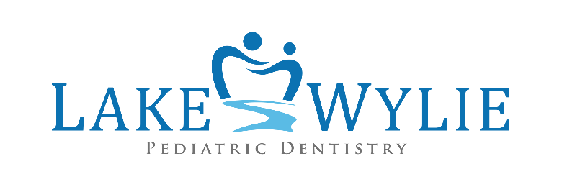

LAKE WYLIE PEDIATRIC DENTISTRY
Notice of Privacy Practices

THIS NOTICE DESCRIBES HOW YOUR HEALTH INFORMATION MAY BE USED AND DISCLOSED BY LAKE WYLIE PEDIATRC DENTISTRY AND HOW YOU CAN GET ACCESS TO THIS INFORMATION. PLEASE REVIEW IT CAREFULLY.

YOUR RIGHTS: When it comes to your health information you have certain rights. This section explains your rights.

Upon written request:

- Ask to see or get an electronic or a paper copy of your health record or other information we have about you. We will also provide a summary of your health information if requested. We will charge a reasonable, cost based fee. We will provide this information as soon as possible but no later than 30 working days of the request.
- Ask us to correct your health information you think is incorrect or incomplete. We may say “no” but will tell you why in writing within 60 days.
- You can ask us to communicate with you in a certain way (for example, home or office phone) or to send mail to a different address. We will accommodate all reasonable requests.
- Ask us not to use or share certain health information for treatment, payment or our operations. We are not required to agree with your request and may say “no” if it would affect your care.
- If you pay for a service or health care item out of pocket in full and you ask us not to share that information for payment or our operations with your health insurer we will agree unless we are required by law to share that information.
- Ask us for a list or an accounting of the times we have shared your health information for reasons other than treatment, payment, healthcare operations, and when you have asked us to share information. We will provide a list for the past six years for the request. One request per year will be provided free of charge. For additional requests we will charge a reasonable, cost based fee.
- Revoke an authorization to use or disclose PHI at any time except where action has already been taken.

You may also:

- Choose someone to act on your behalf. If you have given someone medical power of attorney or they are your legal guardian, that person can exercise your rights and make choices about your health information. We will ask for proof of this relationship before we take any action.
- Ask for a paper copy of this document even if you have agreed to receive the notice electronically. We will provide that copy promptly.
- File a complaint. If you feel your rights have been violated you may contact the designated Privacy Office: Patient Care Coordinator 534 Nautical Drive Lake Wylie, SC 29710 803-619-5155(P) 803-619-6575(F) office@lakewyliepediatricdentistry.com
- File a complaint with the US Department of Health and Human Services Office for Civil Rights by sending a letter to 200 Independence Ave, S.W., Washington, D.C. 20201, calling 1.877.696.6775, or visiting www.hhs.gov/ocr/privacy/hipaa/complaints.
- We will not retaliate for filing a complaint.

OUR RESPONSIBILITIES: The law requires us to:
- Maintain the privacy and security of your protected health information.
- Notify you promptly if a breach occurs that may compromise the privacy or security of your information.
- Follow the duties and privacy practices described in this notice and give you a copy of it.
- Not to use or share you information other what is described in this notice unless you tell us we can in writing. If you tell us we can and then change your mind, just let us know in writing you have changed your mind.

Lake Wylie Pediatric Dentistry 534 Nautical Drive Lake Wylie, SC 29710 803-619-5155(P) 803-619-6575(F)

YOUR CHOICES - For certain health information, you can tell us your choices about what we share. If you have a clear preference for how we share your information in situations described below, talk to us.

- In these cases you have both the right and the choice to tell us to: share information with your family, close friends, or others involved in your care and share information in a disaster relief situation.

If you are not able to tell us your preference, for example if you are unconscious, we may go ahead and share your information if we believe it is in your best interest. We may also share your information when needed to lessen a serious and imminent threat to health or safety.

- In these cases we never share your information unless you give us written permission:
- Marketing purposes
- Sale of your information
- Most sharing of psychotherapy notes
- In the case of fundraising, we may contact you for fundraising efforts, but you can tell us not to contact you again.
OUR USES AND DISCLOSURE – We typically use or share your health information in the following ways:

Treatment: We can use your health information and share it with other professionals who are treating you. Example: we may share your health information to an outside doctor for referral. We will also provide your health care providers with copies of various reports to assist them in your treatment.
Payment: We can use or share your health information to bill and get payment from health plans or other entities. Example: we give information about you to your health insurance plan so it will pay for your healthcare.
Health Care Operations: We can use and share your health information to run our practice, improve your care, and contact you when necessary. Example: we use health information about you to manage your treatment and services.

Other ways we can use or share your health information – We are allowed or required to share your information in other ways – usually in ways that contribute to the public good, such as public health and research. We have to meet many conditions in the law before we can share your information for these purposes.

- Help with public health and safety issues: We can share health information about you for certain situations such as: preventing disease, helping with product recalls, reporting adverse reactions to medication, reporting suspected abuse, neglect, or domestic violence, and preventing or reducing a serious threat to anyone’s health and safety.
- Comply with the law: We will share information about you if state or federal laws require it, including with the Department of Health and Human Services if it wants to see if we are complying with federal privacy law.
- Respond to organ and tissue donation requests: We will share health information about you with organ procurement organizations.
- Work with a medical examiner or funeral director: We can share health information with a coroner, medical examiner, or funeral director when you die.
- Address workers’ compensation, law enforcement, and other government requests:
  - For workers’ compensation claims
  - For law enforcement purposes or with a law enforcement official
  - With health oversight agencies for activities authorized by law
  - For special government functions such as military, national security, and presidential protective services
- Respond to lawsuits and legal actions: We can share your health information to respond to a court or administrative order, or in response to a subpoena.
- Research: We can use or share your information for health research.

CHANGES TO THIS NOTICE - We can change the terms of this notice, and the changes will apply to all information we have about you. The new notice will be available upon request, in our office and on our website.

Patient Care Coordinator
office@LakeWyliePediatricDentistry.com
803-619-5155

Effective date: June 1st, 2016

